LAB 321Assignment | Type: | ShortAssignment
LAB 321Assignment | Code: | J3.L.P0066
LAB 321Assignment | LOC: | 300
LAB 321Assignment | Slot(s): | 10

Title: Restaurant Details (Nếu chọn bài này thì không được lựa chọn bài P0064)

Background
Restaurant provide services that customer can order a party online. The restaurant also has promotion programs

Program Specifications

Program a web site display the detailed information of a restaurant

Features:

This website contains following main functions
- Function 1: Login
- Function 2: Display Restaurant Details
  - View detailed information
  - Add comments
  - Rate restaurant
  - List all comments
- Function 3: Update Restaurant Profile
- Function 4: Add Restaurant Images

Database description
- Database must contain promotion detail information displayed on the screen

Expectation of User interface:

PIC 1: Login

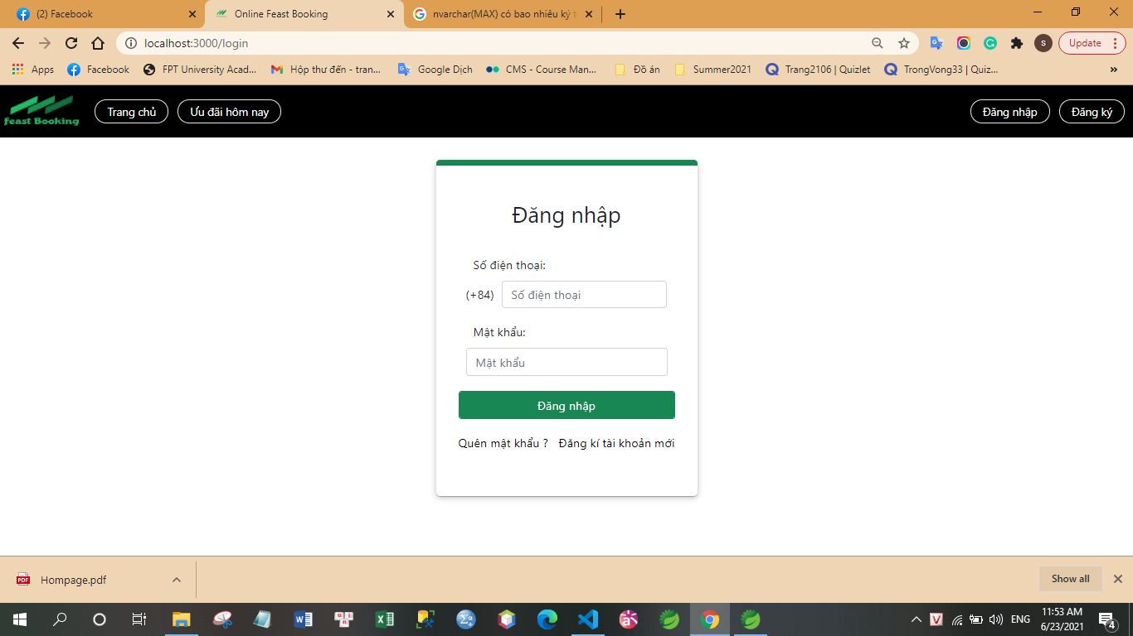

Note: The following fields must be displayed
- Mobile No
- Password
- Login button

PIC 2: Restaurant Details

Note: The following fields must be displayed
- All fields in the screen must be got from database
- When user click on “Back”, the previous picture will be displayed
- When user click on “Next”, the next picture will be displayed
- When user click on “Save”, the promotion list will be displayed

PIC 3: Update Restaurant Details

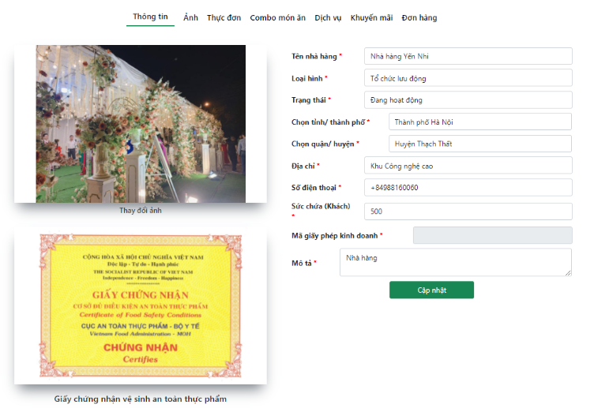

PIC 4: Add Restaurant Images

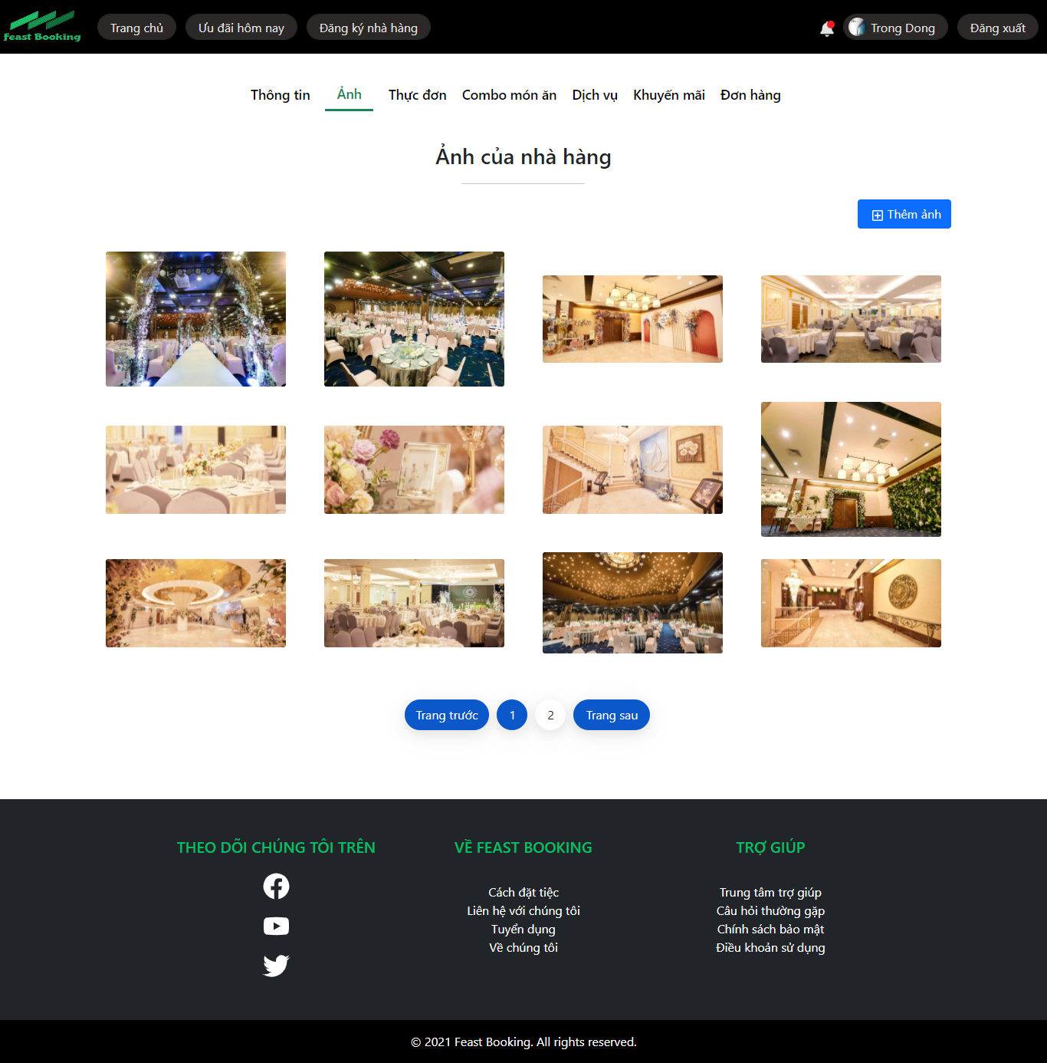

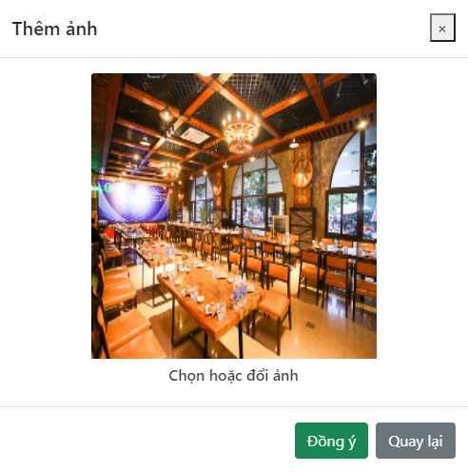

Guidelines
- Step 1 : Create web layout
- Step 2 : Create prototype
- Step 3 : Design database base on created prototype
- Step 4 : Code & Test

